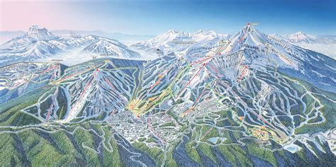
Springboard Data Science career track

Guided Capstone

Project Report
Big Mountain Resort ticket pricing

Introduction
Management at Big Mountain Resort in Montana requested data-driven guidance for ticket pricing. The current ticket price was set by the average of competitor prices, and they hope to do better. Using the nationwide competitive data about each resort’s facilities and ticket prices provided by management, we analyzed which features of a ski resort can affect ticket prices, and built and tested a model to answer the request: What opportunities exist for Big Mountain Resort to select a better value for their ticket prices?

Highest-impact resort features
A positive linear relationship “up and to the right” between a feature and ticket price indicated a need for further investigation.
We identified the following resort features with a positive relationship: vertical_drop, Snow Making_ac, total_chairs, fastQuads, Runs, LongestRun_mi, trams, SkiableTerrain_ac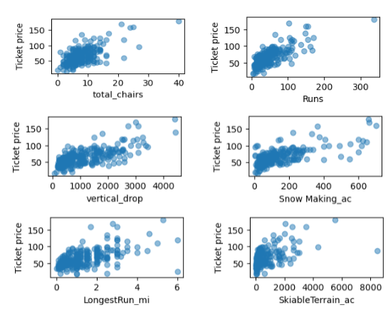
We considered Big Mountain in relation to competitors - price is high relative to other resorts in Montana, and on features such as number of runs, number of chairs, etc., Big Mountain compares favorably to most other resorts nationwide:
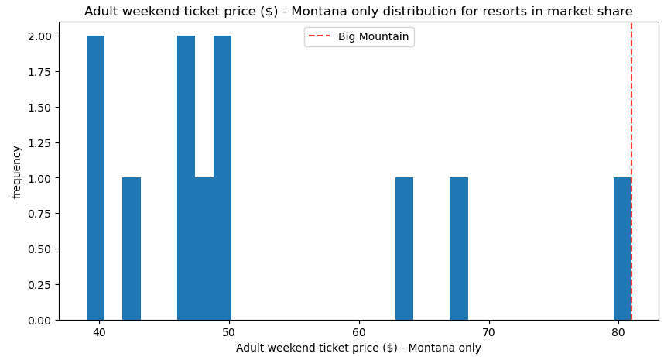
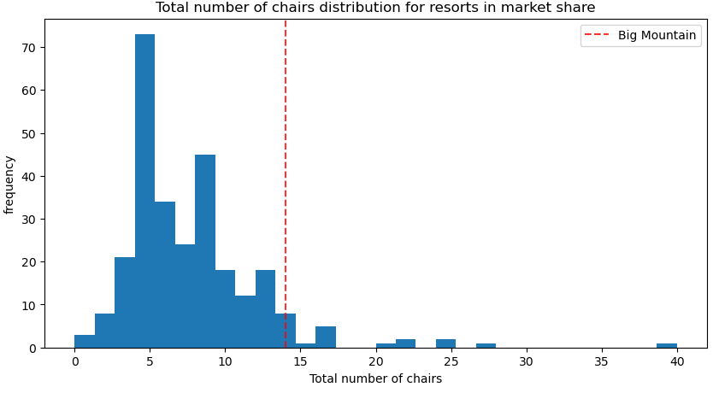
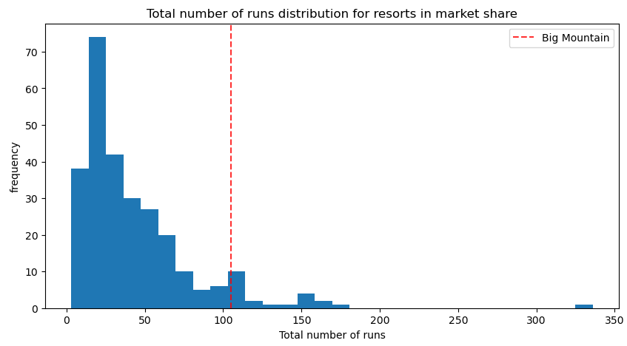
Could Big Mountain change features to increase ticket price and revenue? Assuming the expected number of visitors over the season is 350,000 and, on average, visitors ski for five days, Management proposed the following options:

Management scenario | Financial Impact
Permanently closing down up to 10 of the least used runs. This doesn't impact any other resort statistics. | Closing 1 run makes no difference.  Closing 2 and 3 successively reduces support for ticket price and so revenue. If Big Mountain closes down 3 runs, it seems they may as well close down 4 or 5 as there's no further loss in ticket price. Increasing the closures down to 6 or more leads to a large drop.
Increase the vertical drop by adding a run to a point 150 feet lower down but requiring the installation of an additional chair lift to bring skiers back up, without additional snow making coverage | This scenario increases support for ticket price by $1.31  Over the season, this could be expected to amount to $2295082
Increase the vertical drop by adding a run to a point 150 feet lower down but requiring the installation of an additional chair lift to bring skiers back up, adding 2 acres of snow making cover | This scenario increases support for ticket price by $1.31  Over the season, this could be expected to amount to $2295082  Such a small increase in the snow making area makes no difference!
Increase the longest run by 0.2 mile to boast 3.5 miles length, requiring an additional snow making coverage of 4 acres | $0  No difference whatsoever.

Further considerations
- The biggest factor for ticket prices was adding chairs. Could more chair lifts be added? How to maximize the customer satisfaction with the existing chairs?
- Who are the current customers? With info from recent customers, understand where do they live, how far do they travel, what other resorts are in the same geographic range for them?
- Market Segmentation and consumer behavior. Which consumers would pay more and/or visit more - for which features? Consider - how profitable is it to attract and serve each segment?
- Look at the fuller revenue improvement picture -- there are some people who care about rentals, ski school, dining, hotels - how can the resort maximize overall revenue from those customers?
- Is there a timing factor to the segments who visit? Can operations or prices be adjusted to maximize revenue with timing? (i.e., Ski Week or Spring Break and families?)
- Consider - is there a way to serve elite skiiers and novices without them getting in each others' way? Do ski and snowboard folks mix well?

